**CMPS 350 Project Phase 1 – Report**

**Education Platform**

**(10% of the course grade)**

**The report must be submitted in Word format only**

|  |  |
| --- | --- |
| **Group Members** | Mohammed Abdullah (222211679)  Ibrahim Eyad Aboulibdah (202001803)  Fahad Salem Al-Eida (202010250)  **Emails:** ma2211679@student.qu.edu.qa; ia2001803@student.qu.edu.qa; fa2010250@student.qu.edu.qa; |
| **GitHub link** | https://github.com/WebProjectCMPS350 |

**Grades :**

**The student fills only the “Implementation Percentage”: Please specify either: *Working (completed x%)*, *Not Working (completed x%)* or *Not done*.**

|  |  |  |  |  |
| --- | --- | --- | --- | --- |
| **Criteria** | **Points** | **Implementation Percentage** | **Implementation Quality** | **Your Grade** |
| Design and implement the app Web UI and navigation using HTML, CSS and JavaScript. Including designing the App Web UI and navigation. | 50 | ***Working (completed 100%)*** |  |  |
| Design and implement the Web API and data access repositories to read/write the app data JSON files. | 30 | ***Working (completed 100%)*** |  |  |
| Application modeling (e.g. UML diagrams) to explain the data entities and the functionalities | 5 | ***Working (completed 100%)*** |  |  |
| Testing documentation using screen shots illustrating the testing results. | 5 | ***Working (completed 100%)*** |  |  |
| Team work quality. Contributions of team members - All members should collaborate and contribute equally to the project. | 5 | ***Working (completed 100%)*** |  |  |
| Project report – description of the implemented app, what is implemented, what is missed .. | 5 | ***Working (completed 100%)*** |  |  |
| **Total** | 100 |  |  |  |
| **Plagiarism, outsourcing, free riders** | -100 |  |  |  |
| **Delivery behind the deadline** | -5 |  |  |  |

**Important remark: In case of copying and/or plagiarism or not being able to explain or answer questions about the implementation, you lose the whole grade.**

**\* Criteria for grading the functionality:**

- The functionality is working: you get 70% of the assigned grade.

- The functionality is not working: you lose 40% of assigned grade.

- The functionality is not implemented: you get 0.

- The remaining grade in all cases from above **is assigned to the quality of the implementation**,

- The grades are distributed on the various use cases, when the design/implementation is partial, you get only the grades of designed/implemented use cases.

Code quality criteria, include:

- Use of meaningful identifiers for variables and functions (e.g. using JavaScript naming conventions)

- Pages are responsive

- Clean code: simple and concise code, no redundancy

- Clean implementation without unnecessary files/code

- Use of comments where necessary

- Proper code formatting and indentation.

**You lose marks** for code duplication, poor/inefficient coding practices, poor naming of identifiers, unclean/untidy submission, and unnecessary complex/poor user interface design.

**Important Remark**:

**[Grades: 100-85]:** Will be given only to **fully functional application** with **all the quality criteria cited above met** and the project has excellent **design for the various functionalities**. **The report is professional**.

**[Grades: 85-80]:** Will be given only **to functional application** **with most of all the quality criteria cited above met** and the project has good design for the various functionalities. **The report is professional**.

**[Grades: 80-75]:** 80% of the application functionalities are functional. The project respects partially the quality criteria. **The report is professional** but misses some information.

The grades are not negotiable. We expect that only a small portion (around 15%) of the class will be able to meet the criteria for the grades **[100-85]. You should work hard to and demonstrate the merits of your application to earn those grades.+**

# Description of your proposed platform

Our proposed platform is QU Student Management System, a web-based application designed to streamline academic and administrative tasks for Qatar University students, instructors, and administrators. The system provides a centralized interface for course management, class scheduling, student enrollment, and grade tracking, and all the 6 requested use cases.

The platform supports multiple user roles:

* Students can see available courses and classes, enroll in them, and view their grades and learning path.
* Instructors can manage the classes they teach, validate and submit student grades.
* Administrators can browse the classes or courses separately; they can filter them based on their status and category. They also can approve class/courses, cancel them, or create a new course/class.

Each of these three roles can search among their displayed courses/classes either by name or category.

The platform focuses on usability, clarity, and security, ensuring each user role interacts only with relevant functionalities. With a clean interface and responsive design, the system aims to enhance educational experience and improve operational efficiency across departments.

# Application Design

# Use case diagram

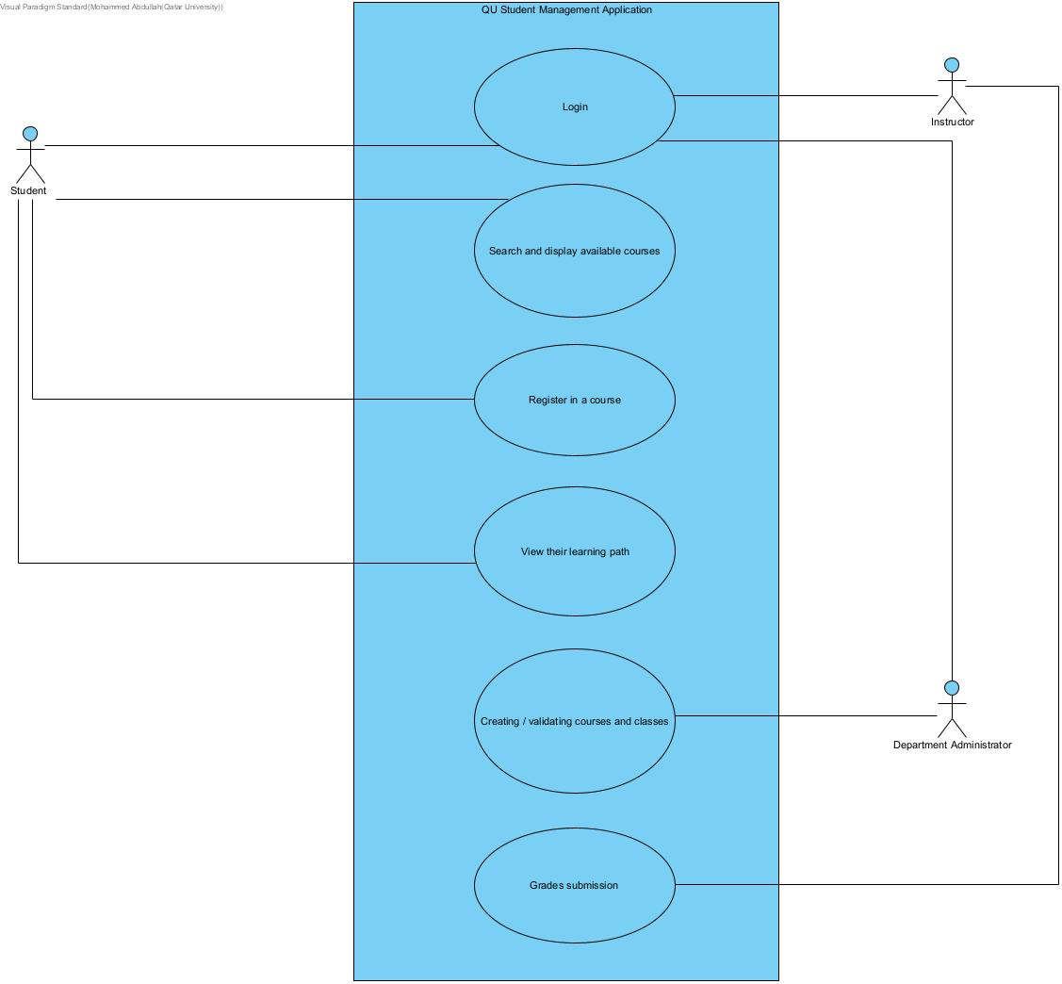

# Entities class diagram

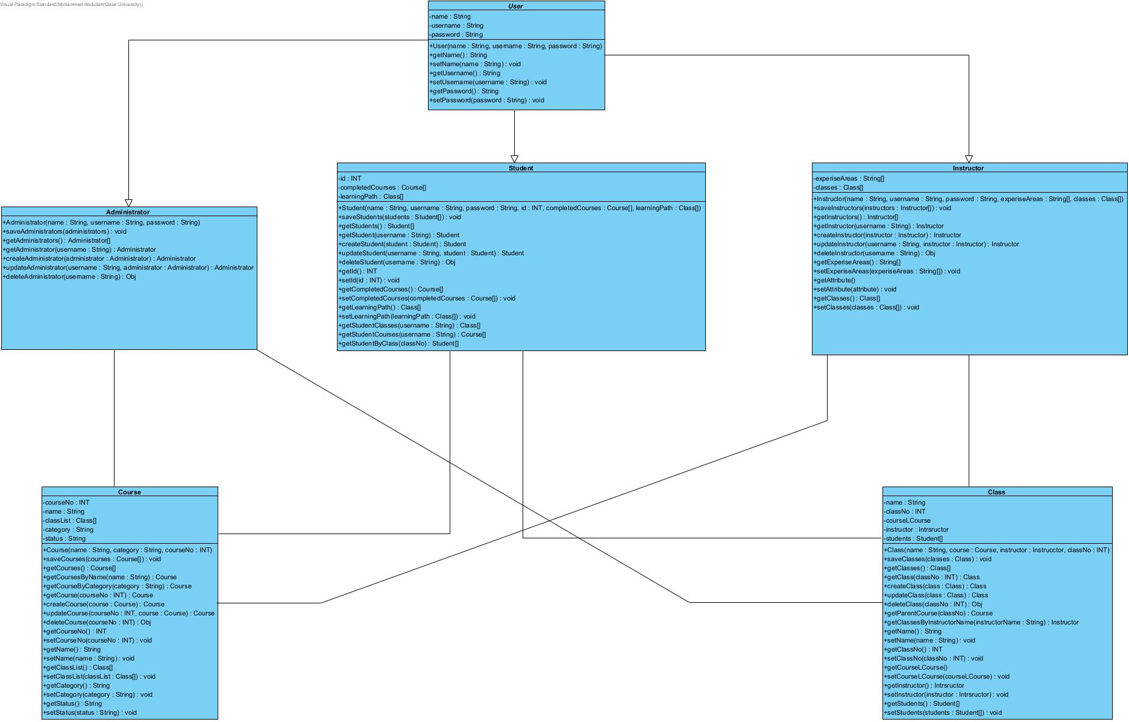

# Web API class

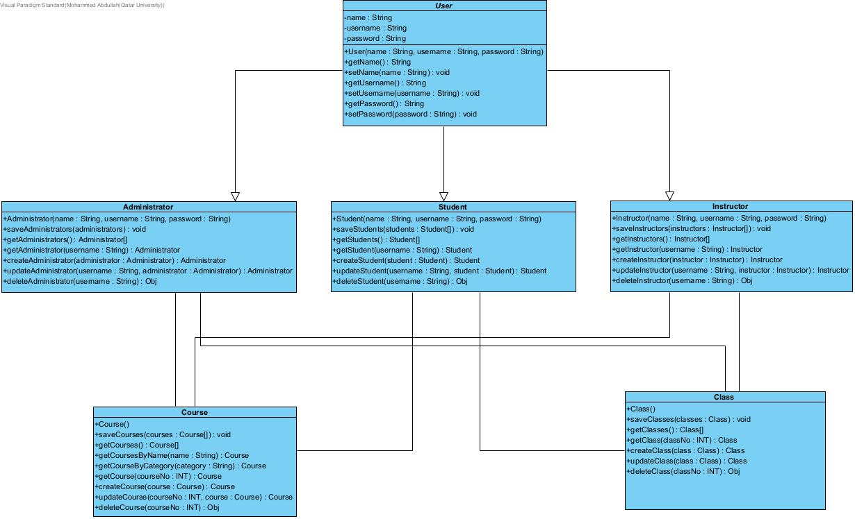

# Implementation

# Implemented use-cases

All of them

# Unimplemented use-cases and not functioning parts

None

# Testing

# Use case 1

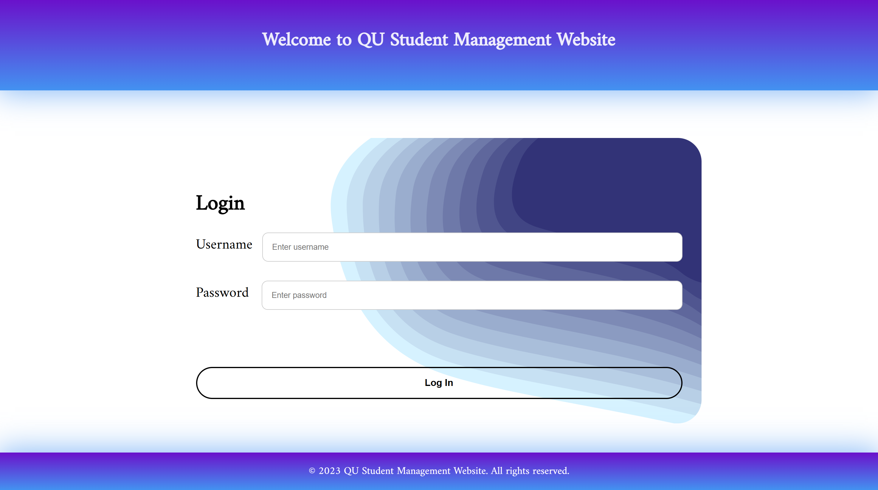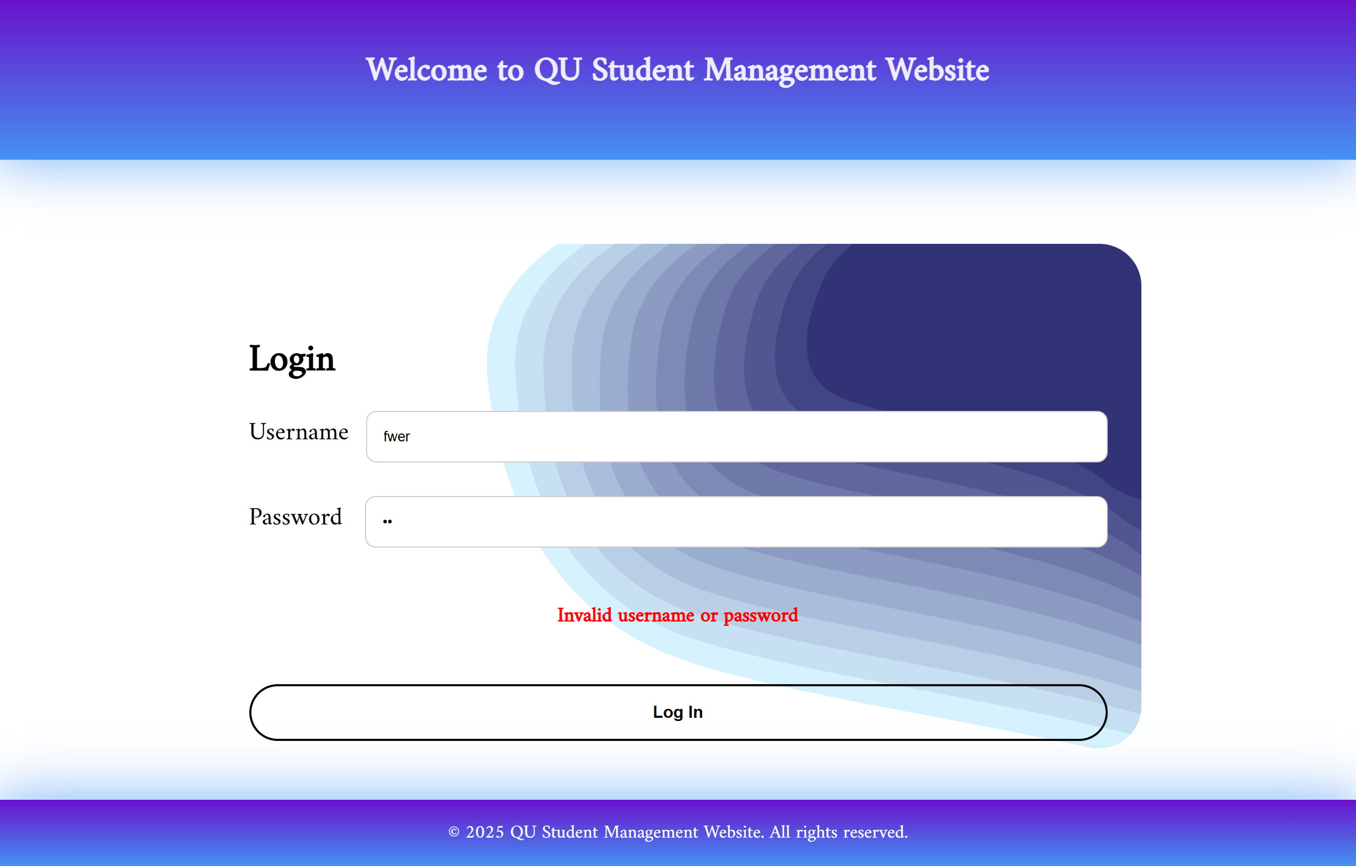

# Use case 2: Display All classes/courses:

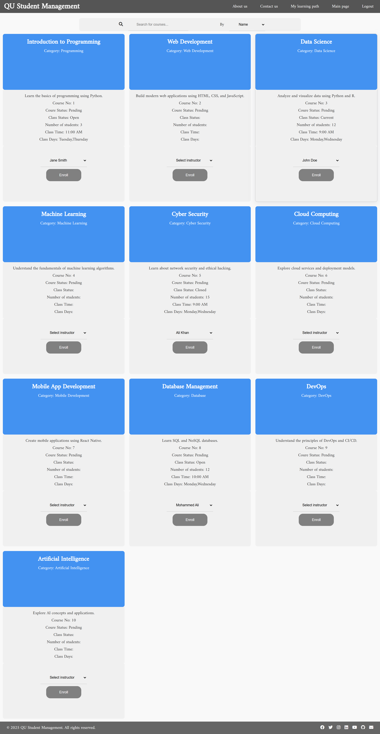

Search for courses:

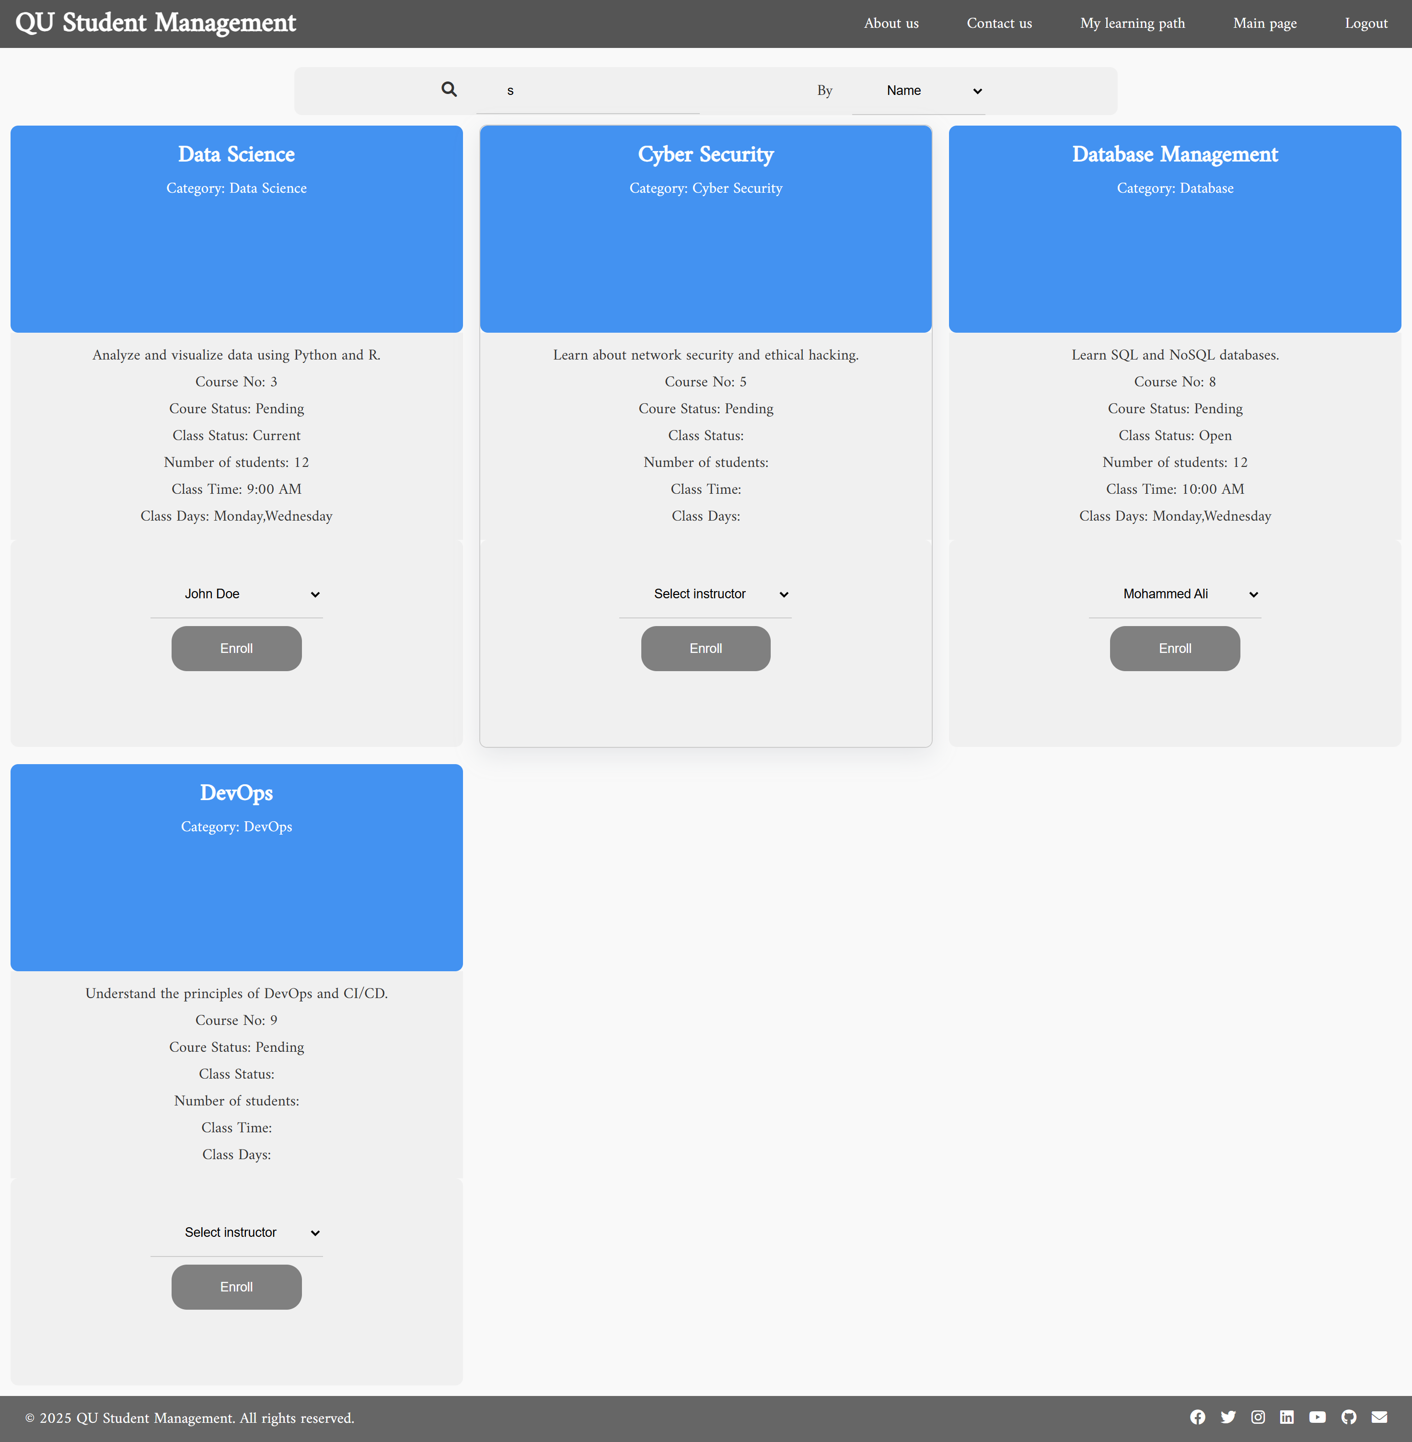

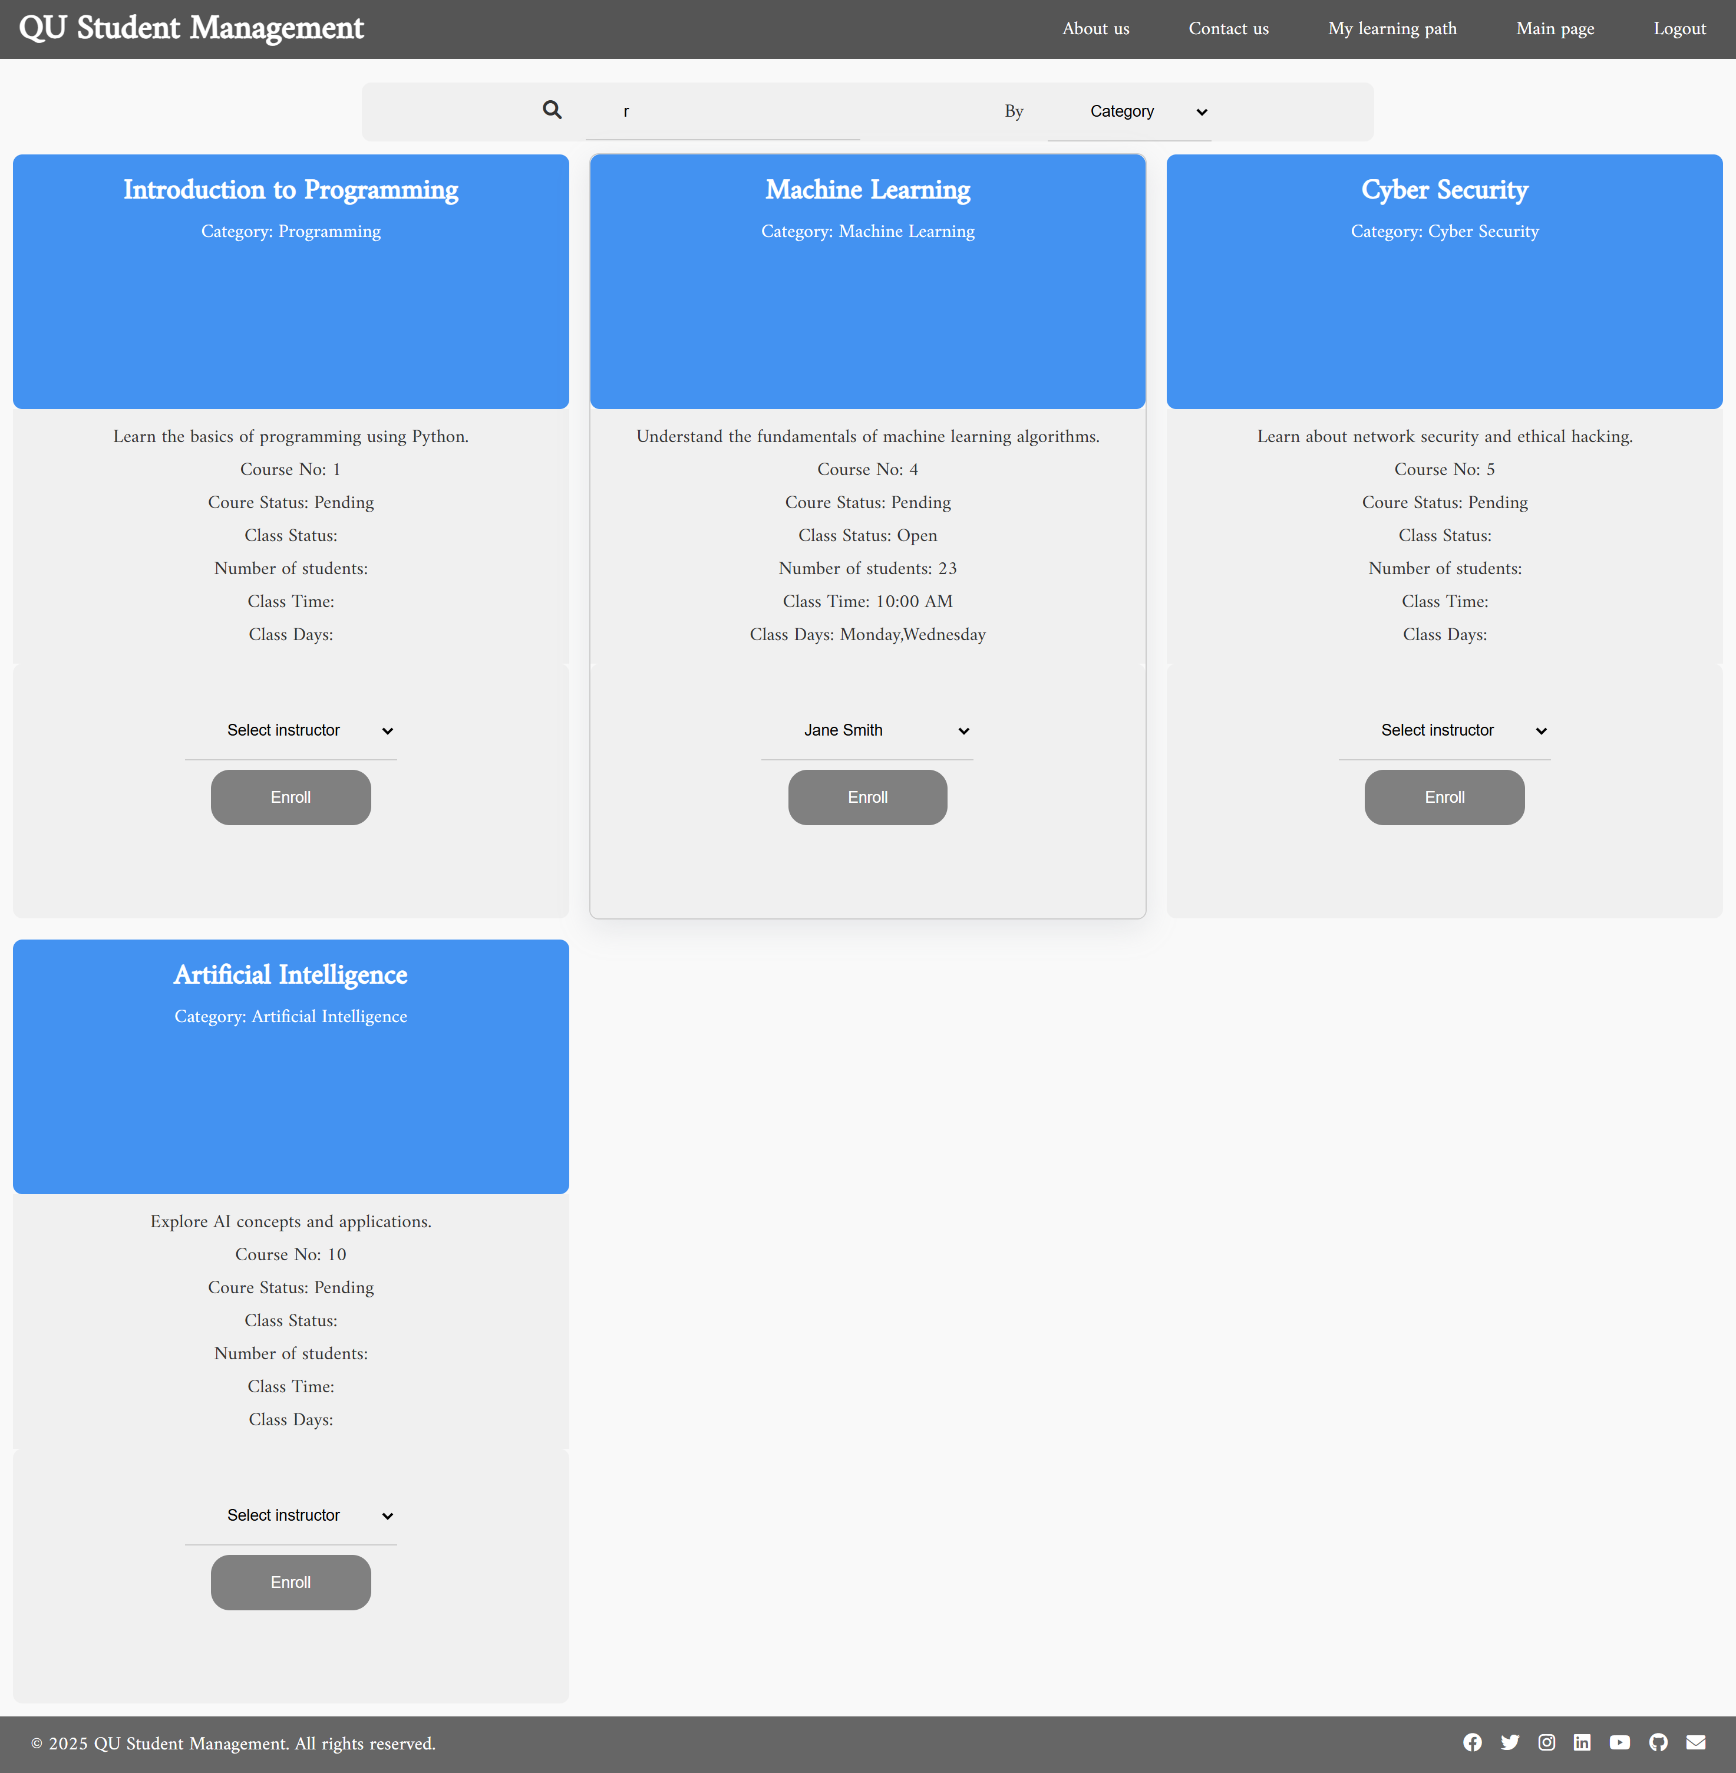

# A screenshot of a computer screen AI-generated content may be incorrect.Use case 3

# Use case 4

# Use case 5

Show classes:

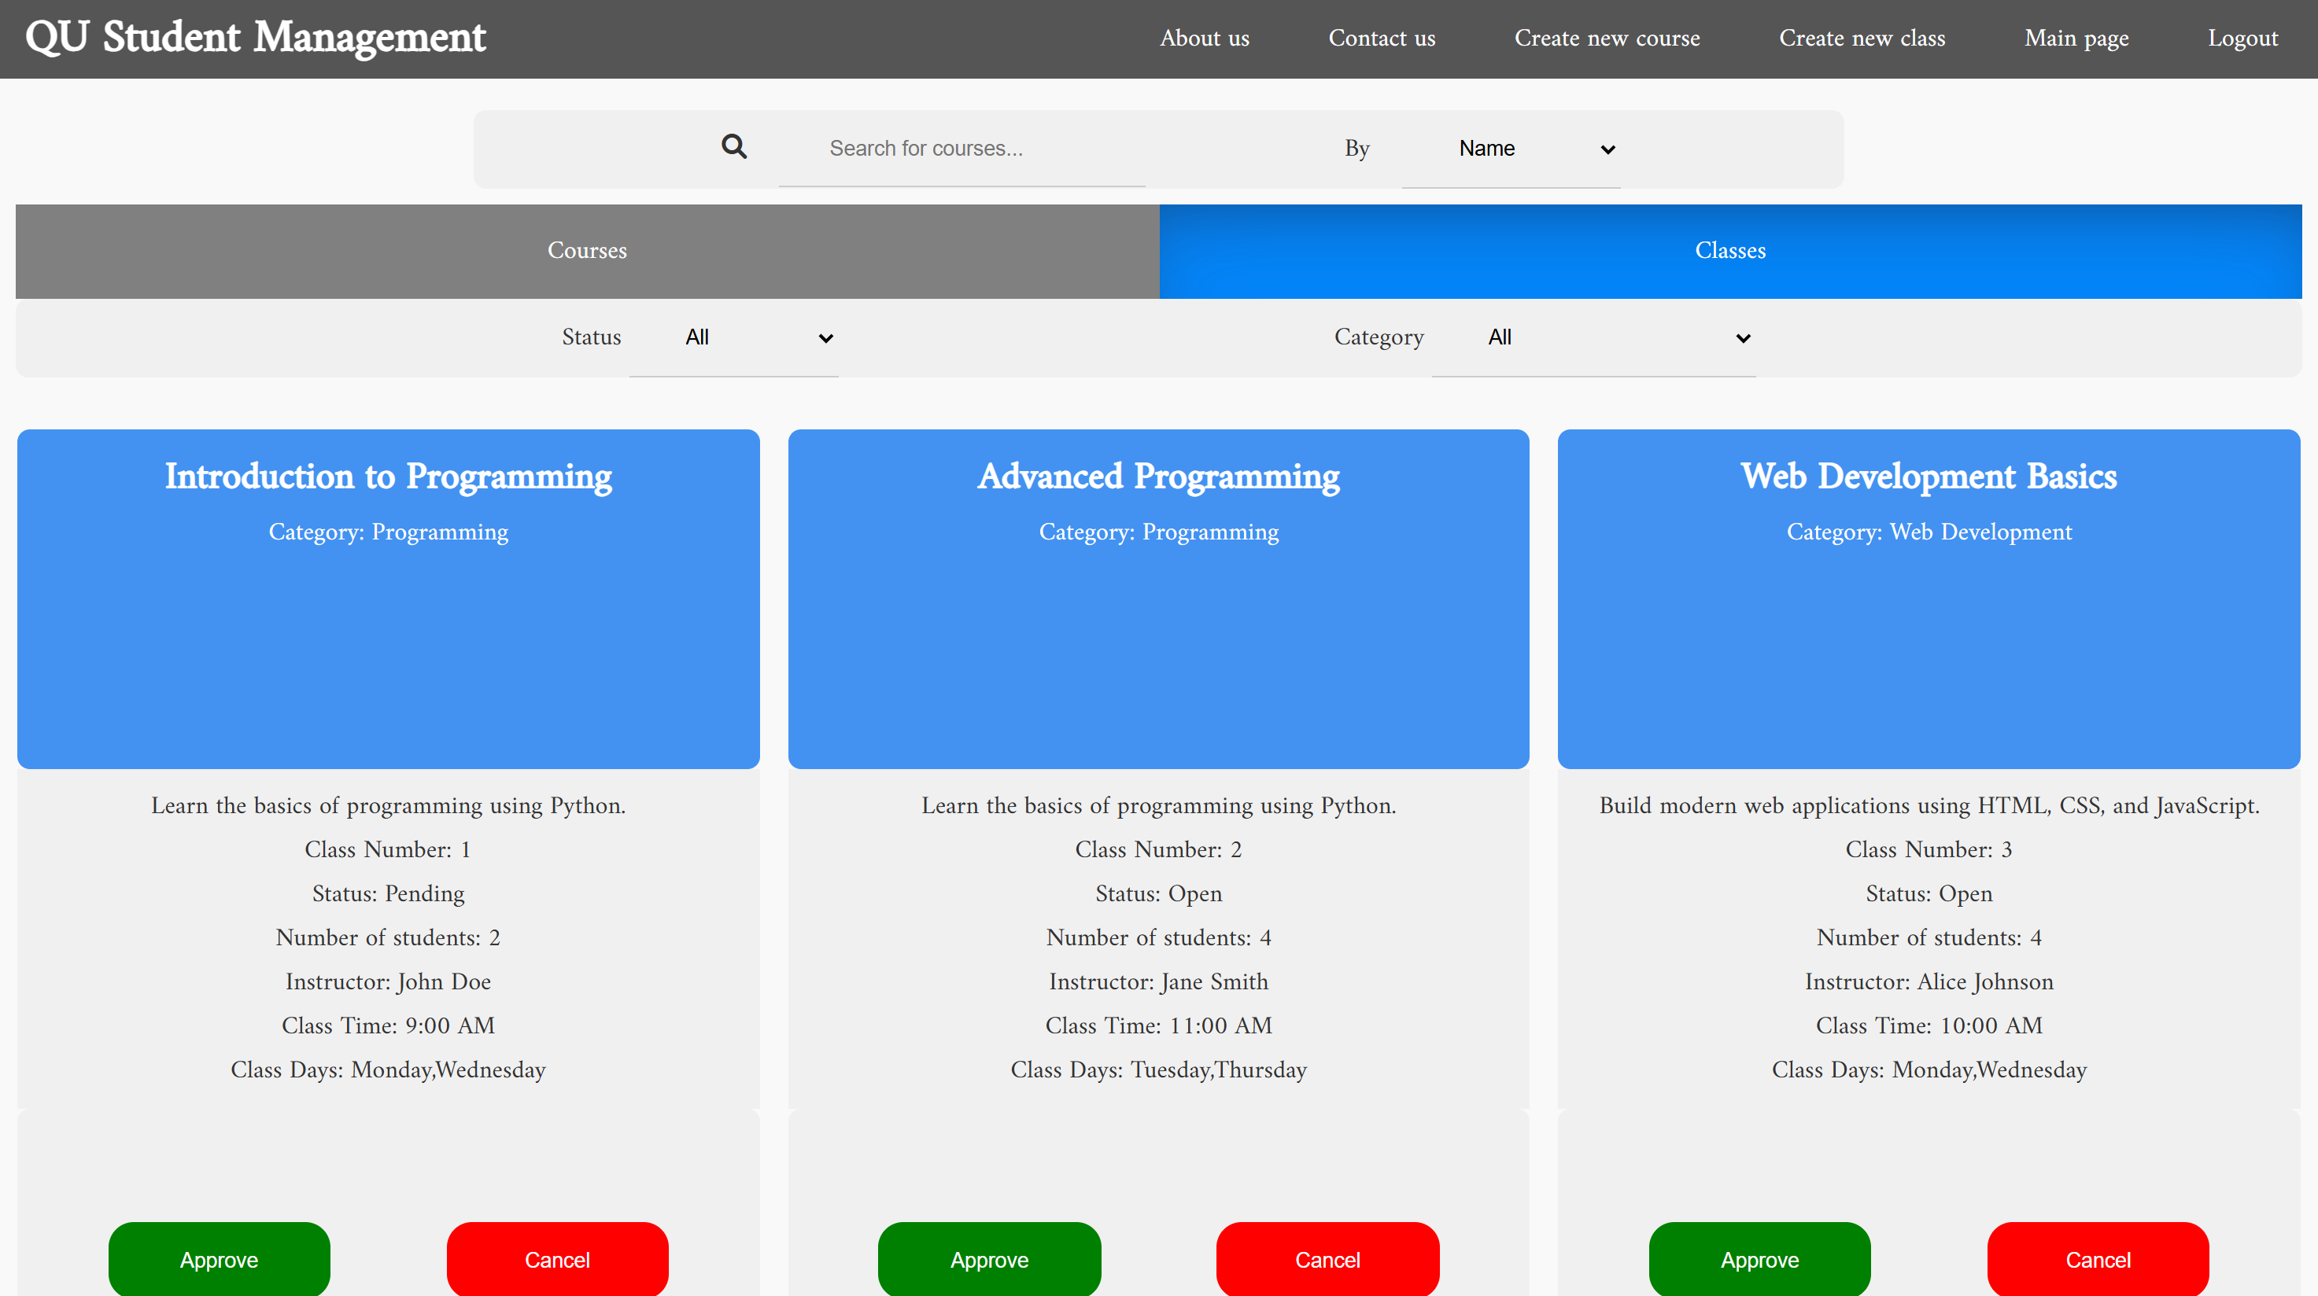

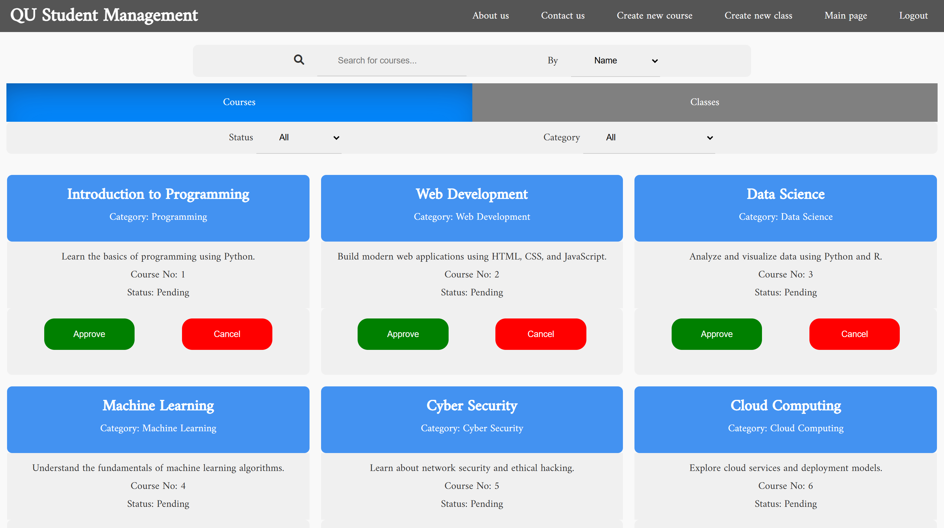Show Courses:

Filter By category:

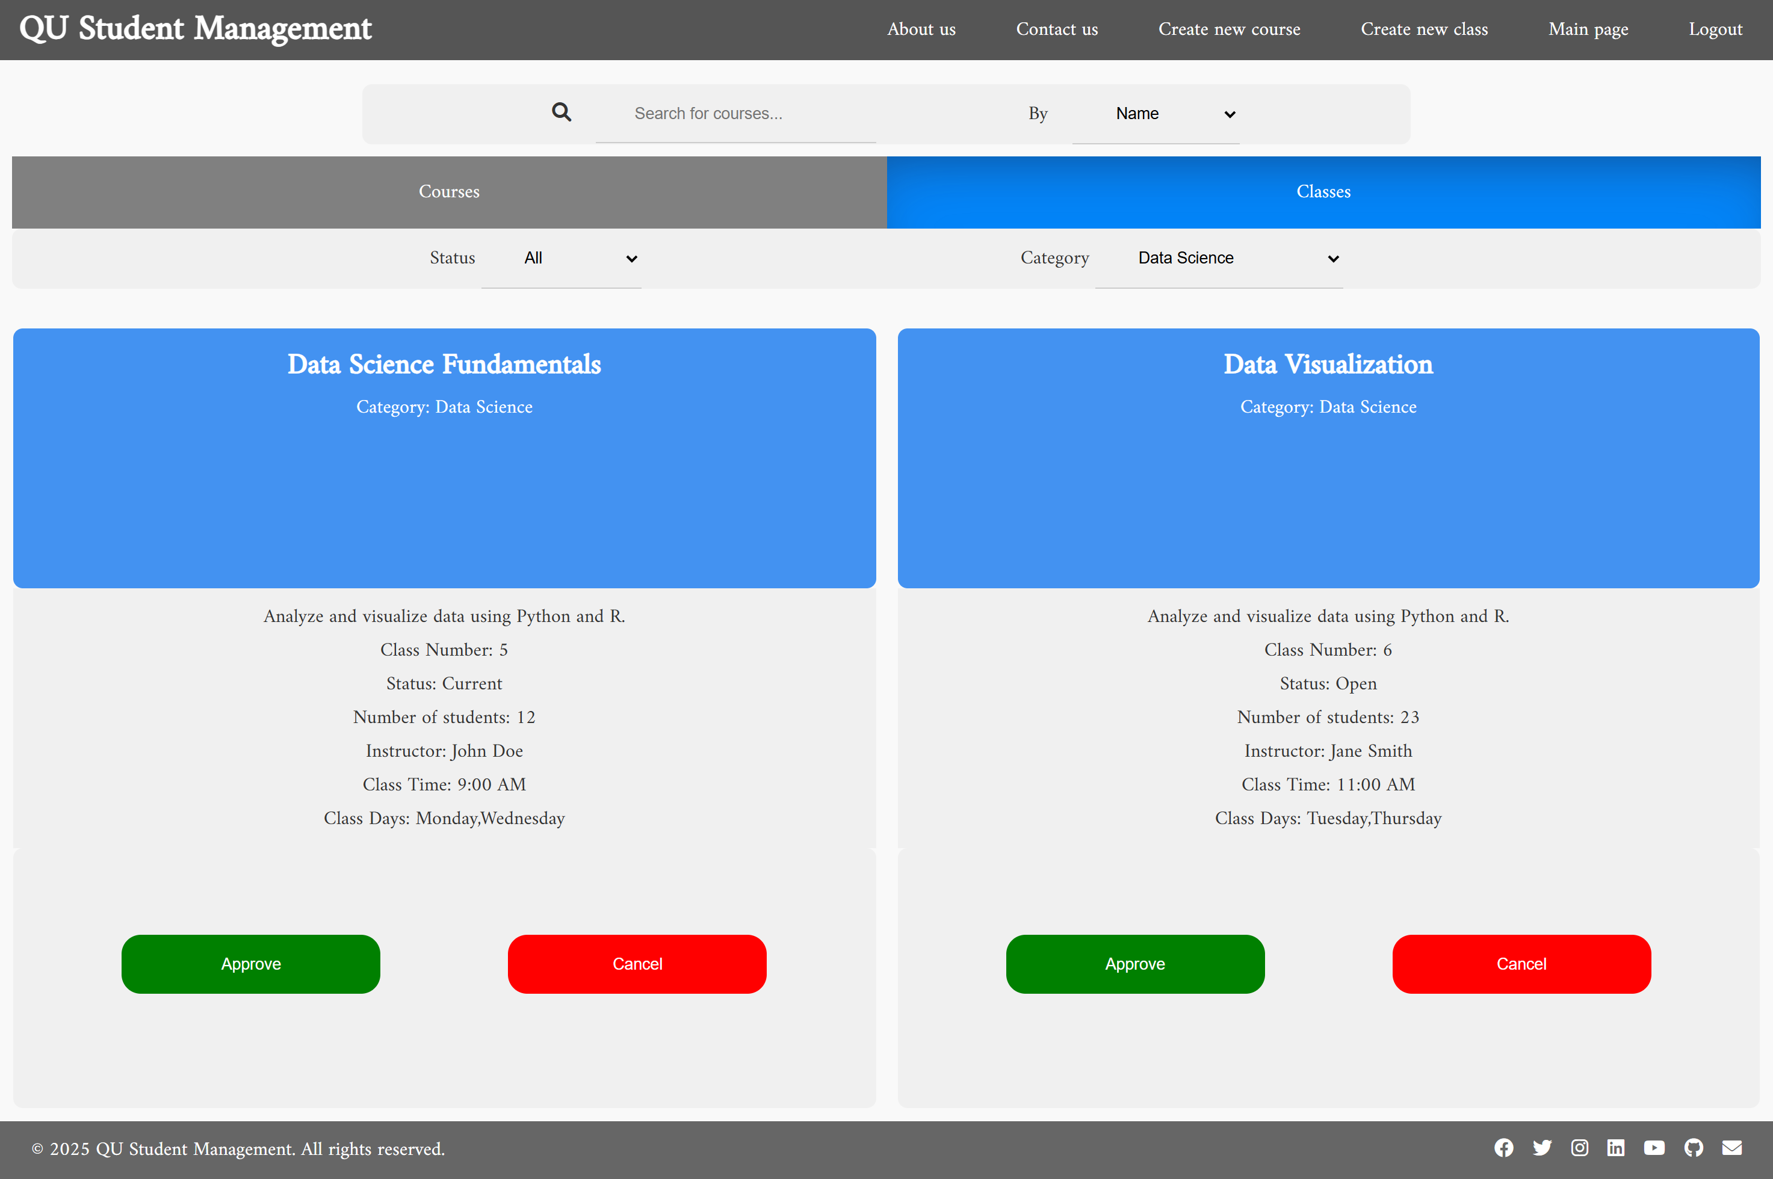

Filter By status:

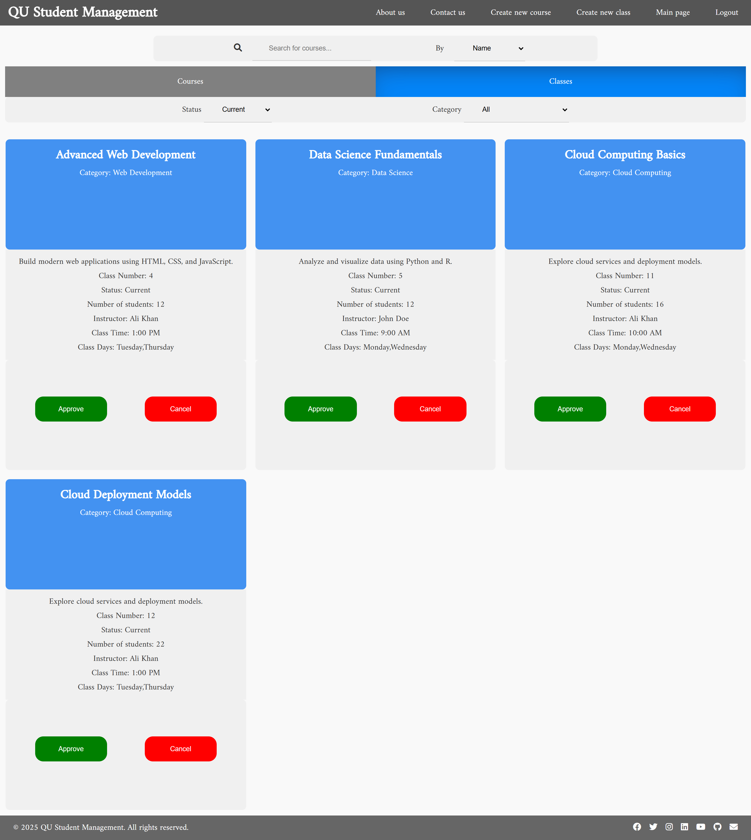

Filter by both:  
  
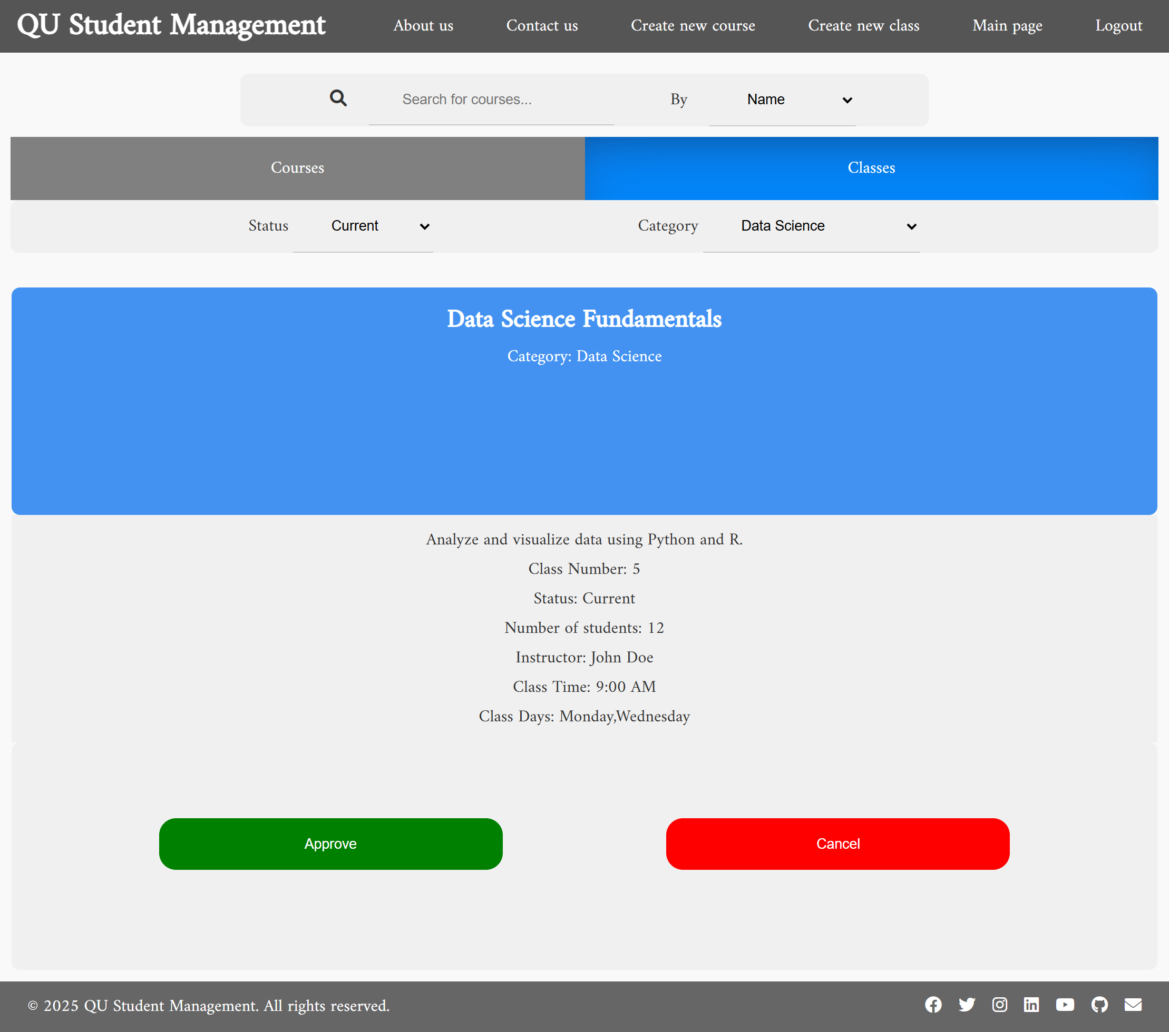

Filter by both with search:

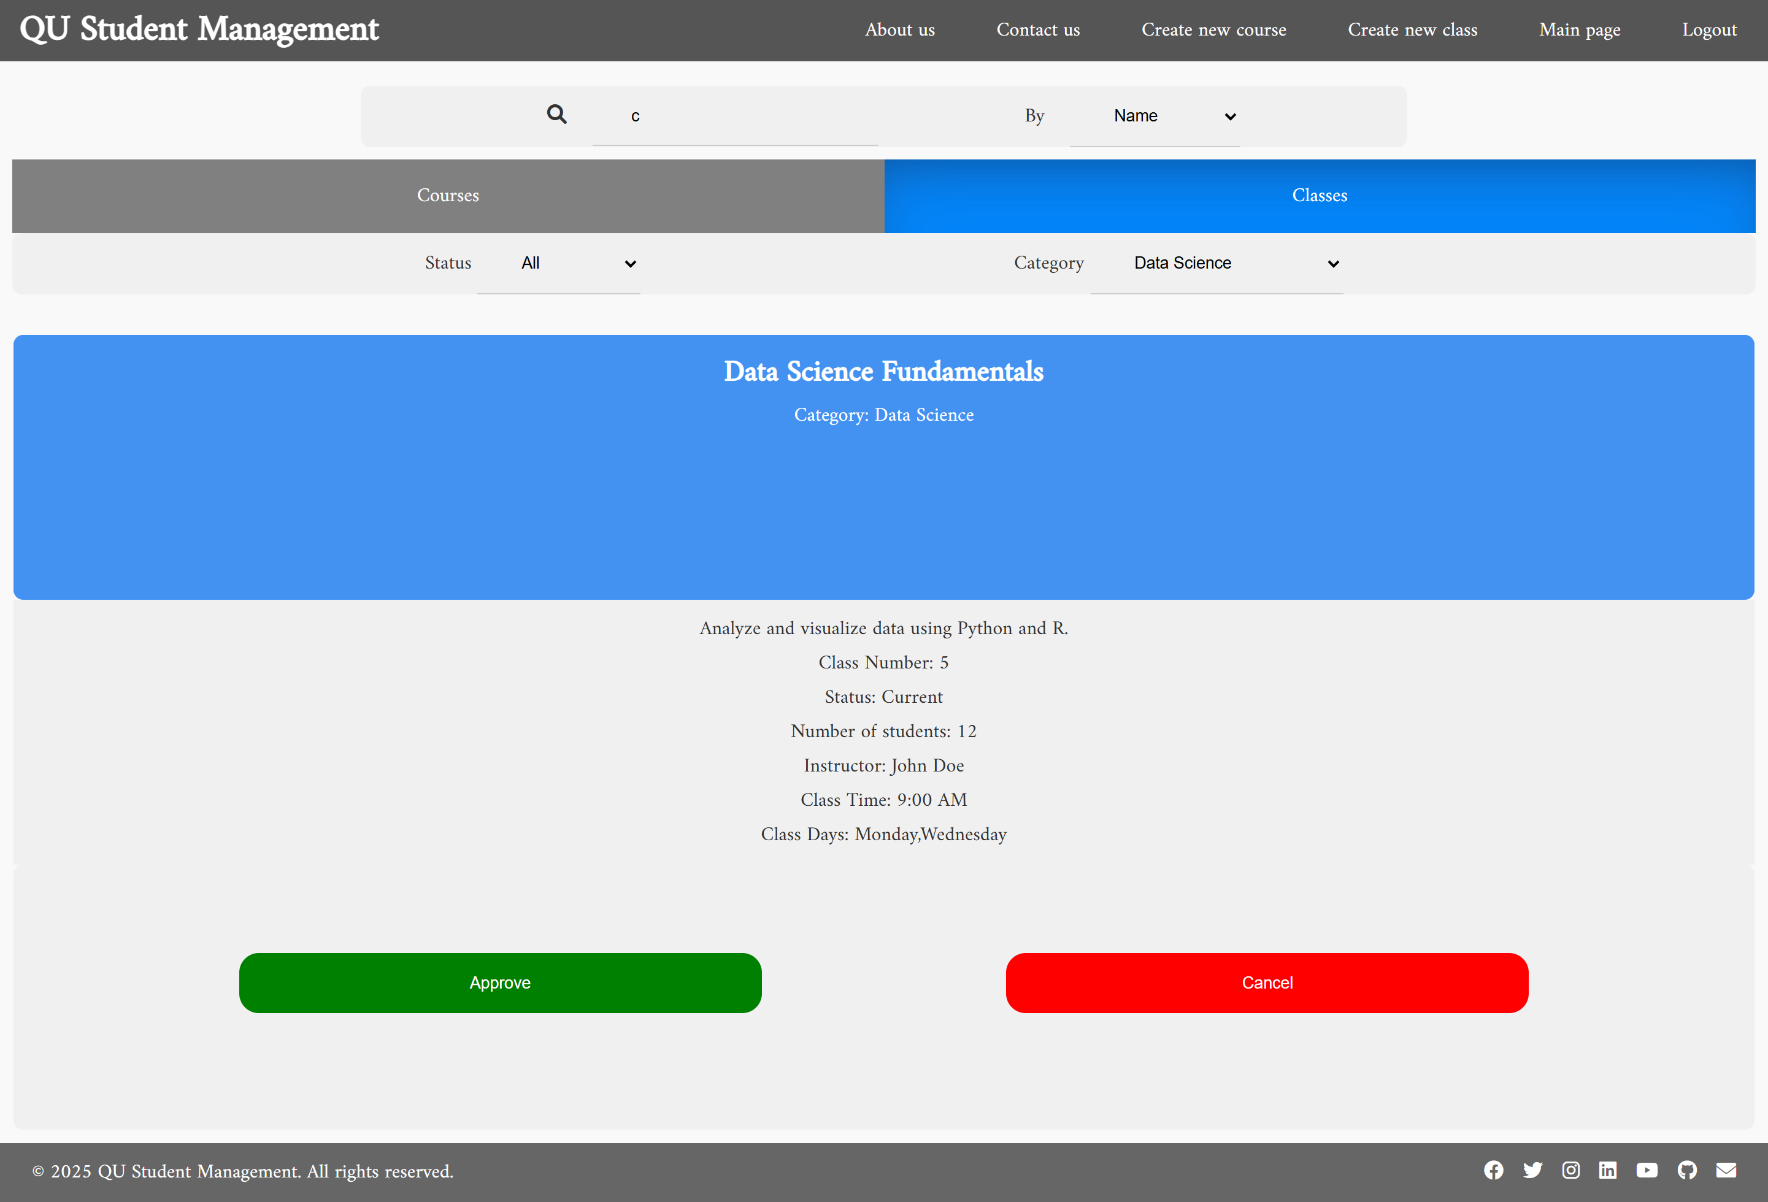

Create Class:

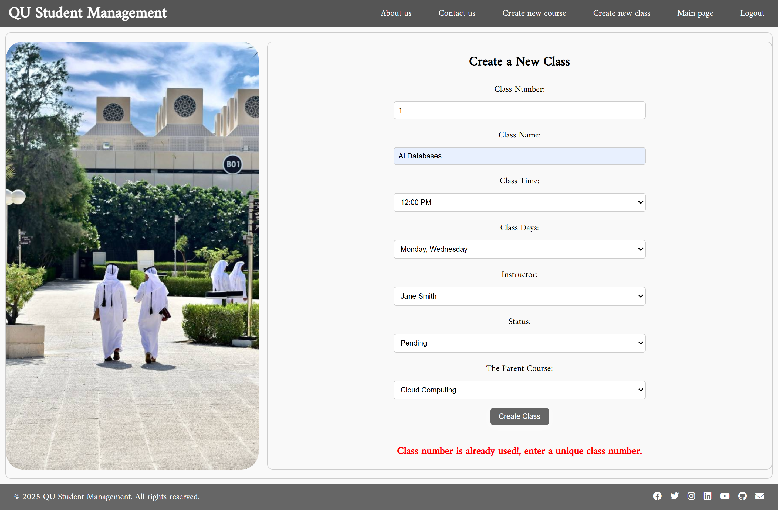

Create a new course:

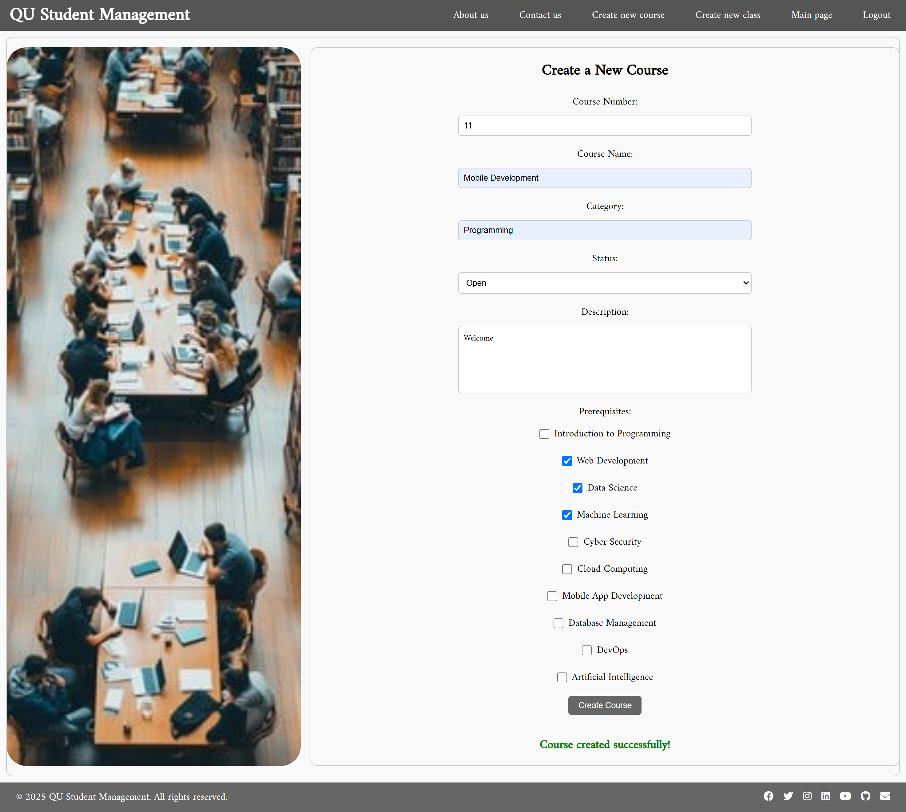

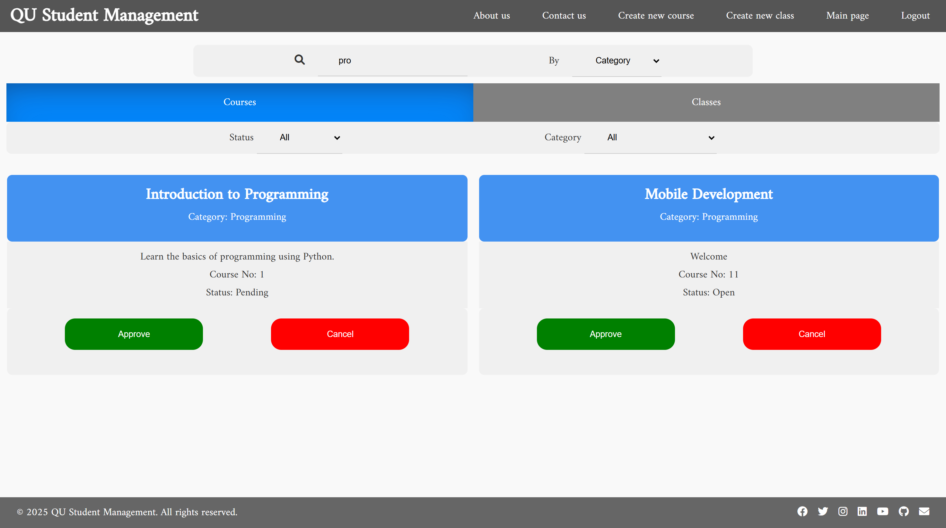

After canceling: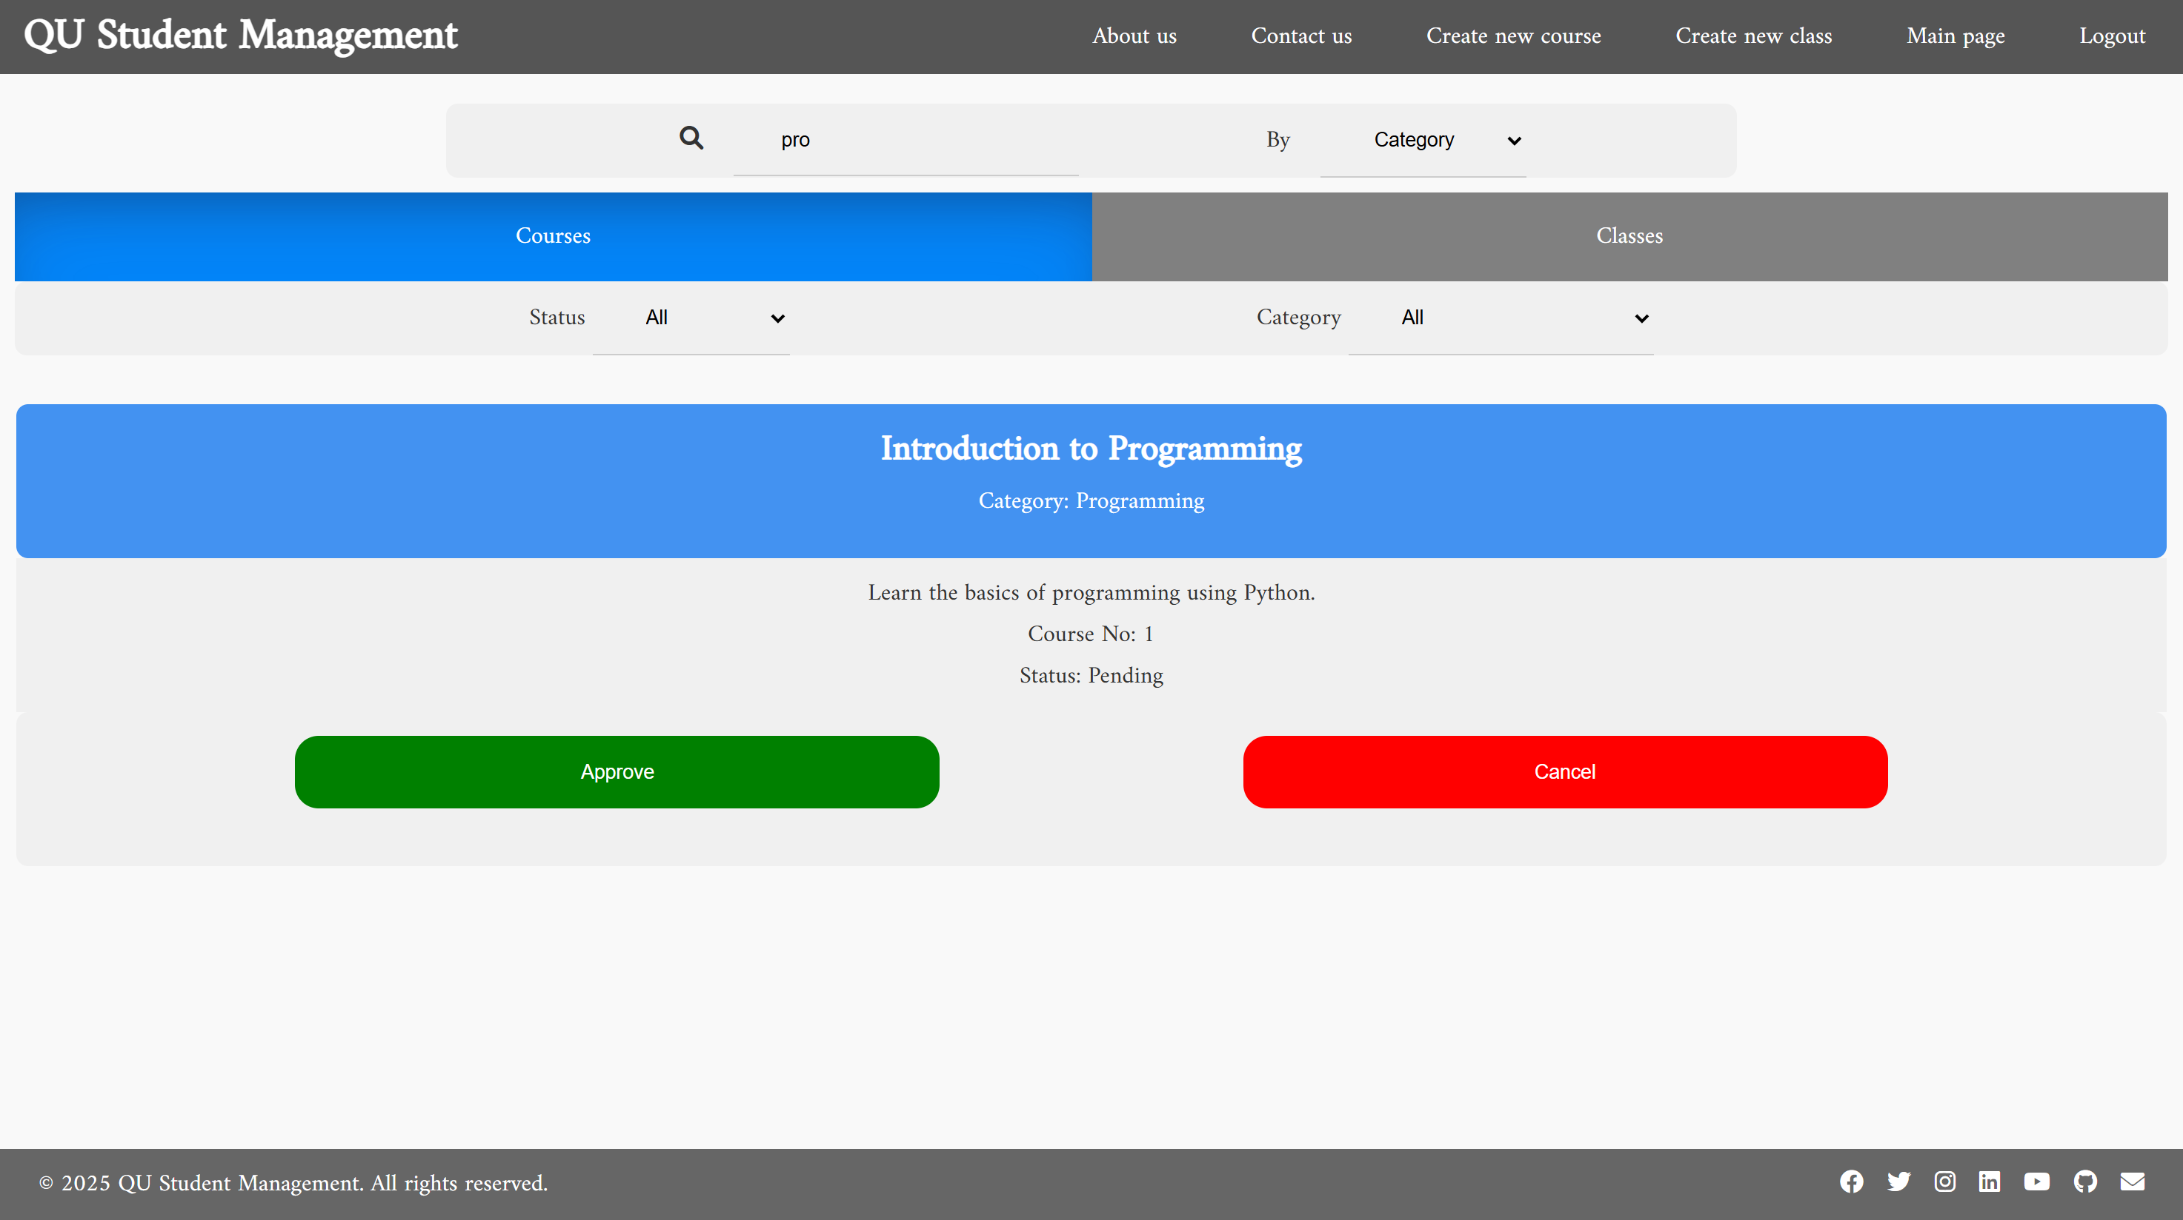

Approving a class:

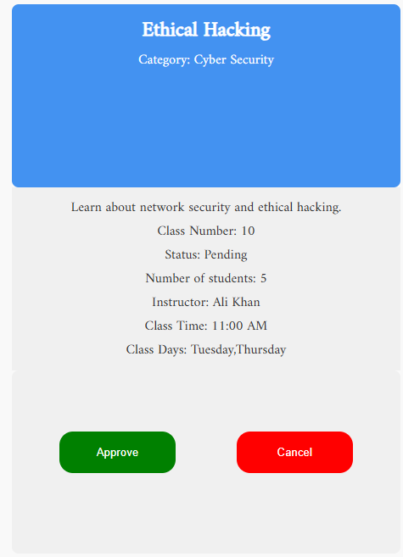

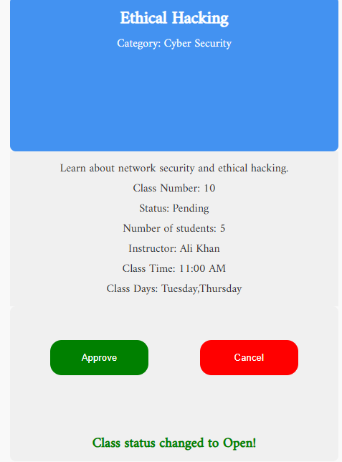  
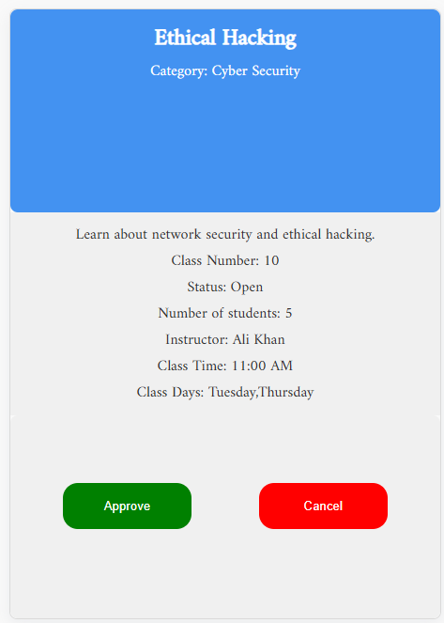

# 3.6 Use case 6:

View instructor classes:

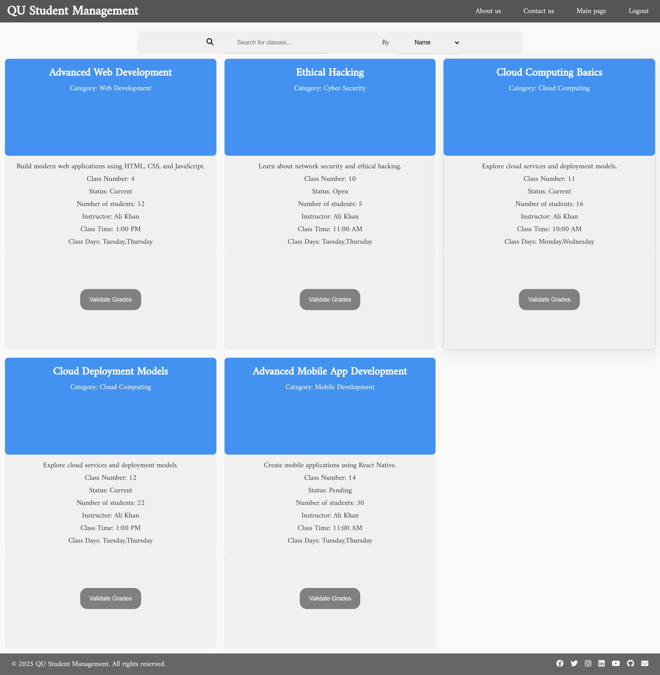

Validate the grades:

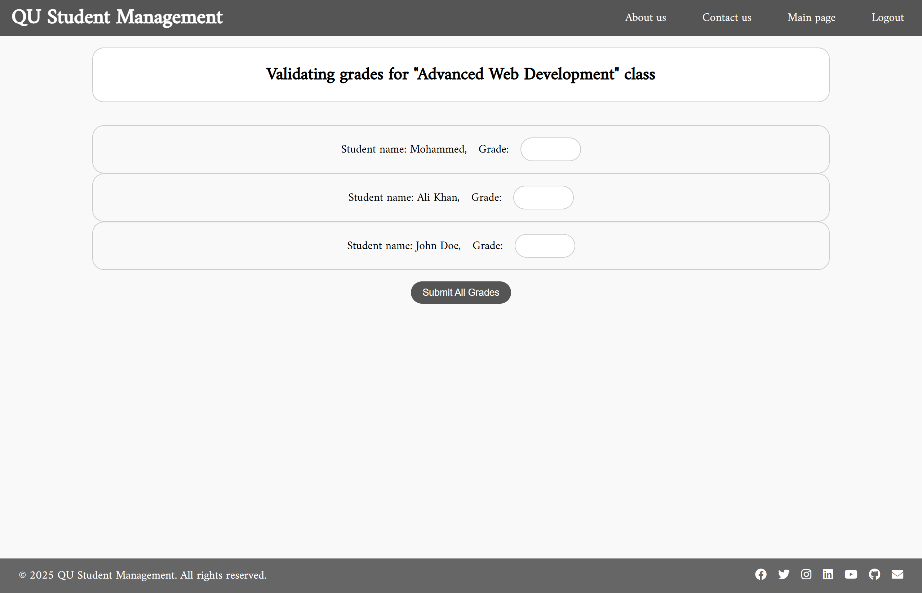

After submitting the final report, the class will be closed and removed from the instructor’s main page:

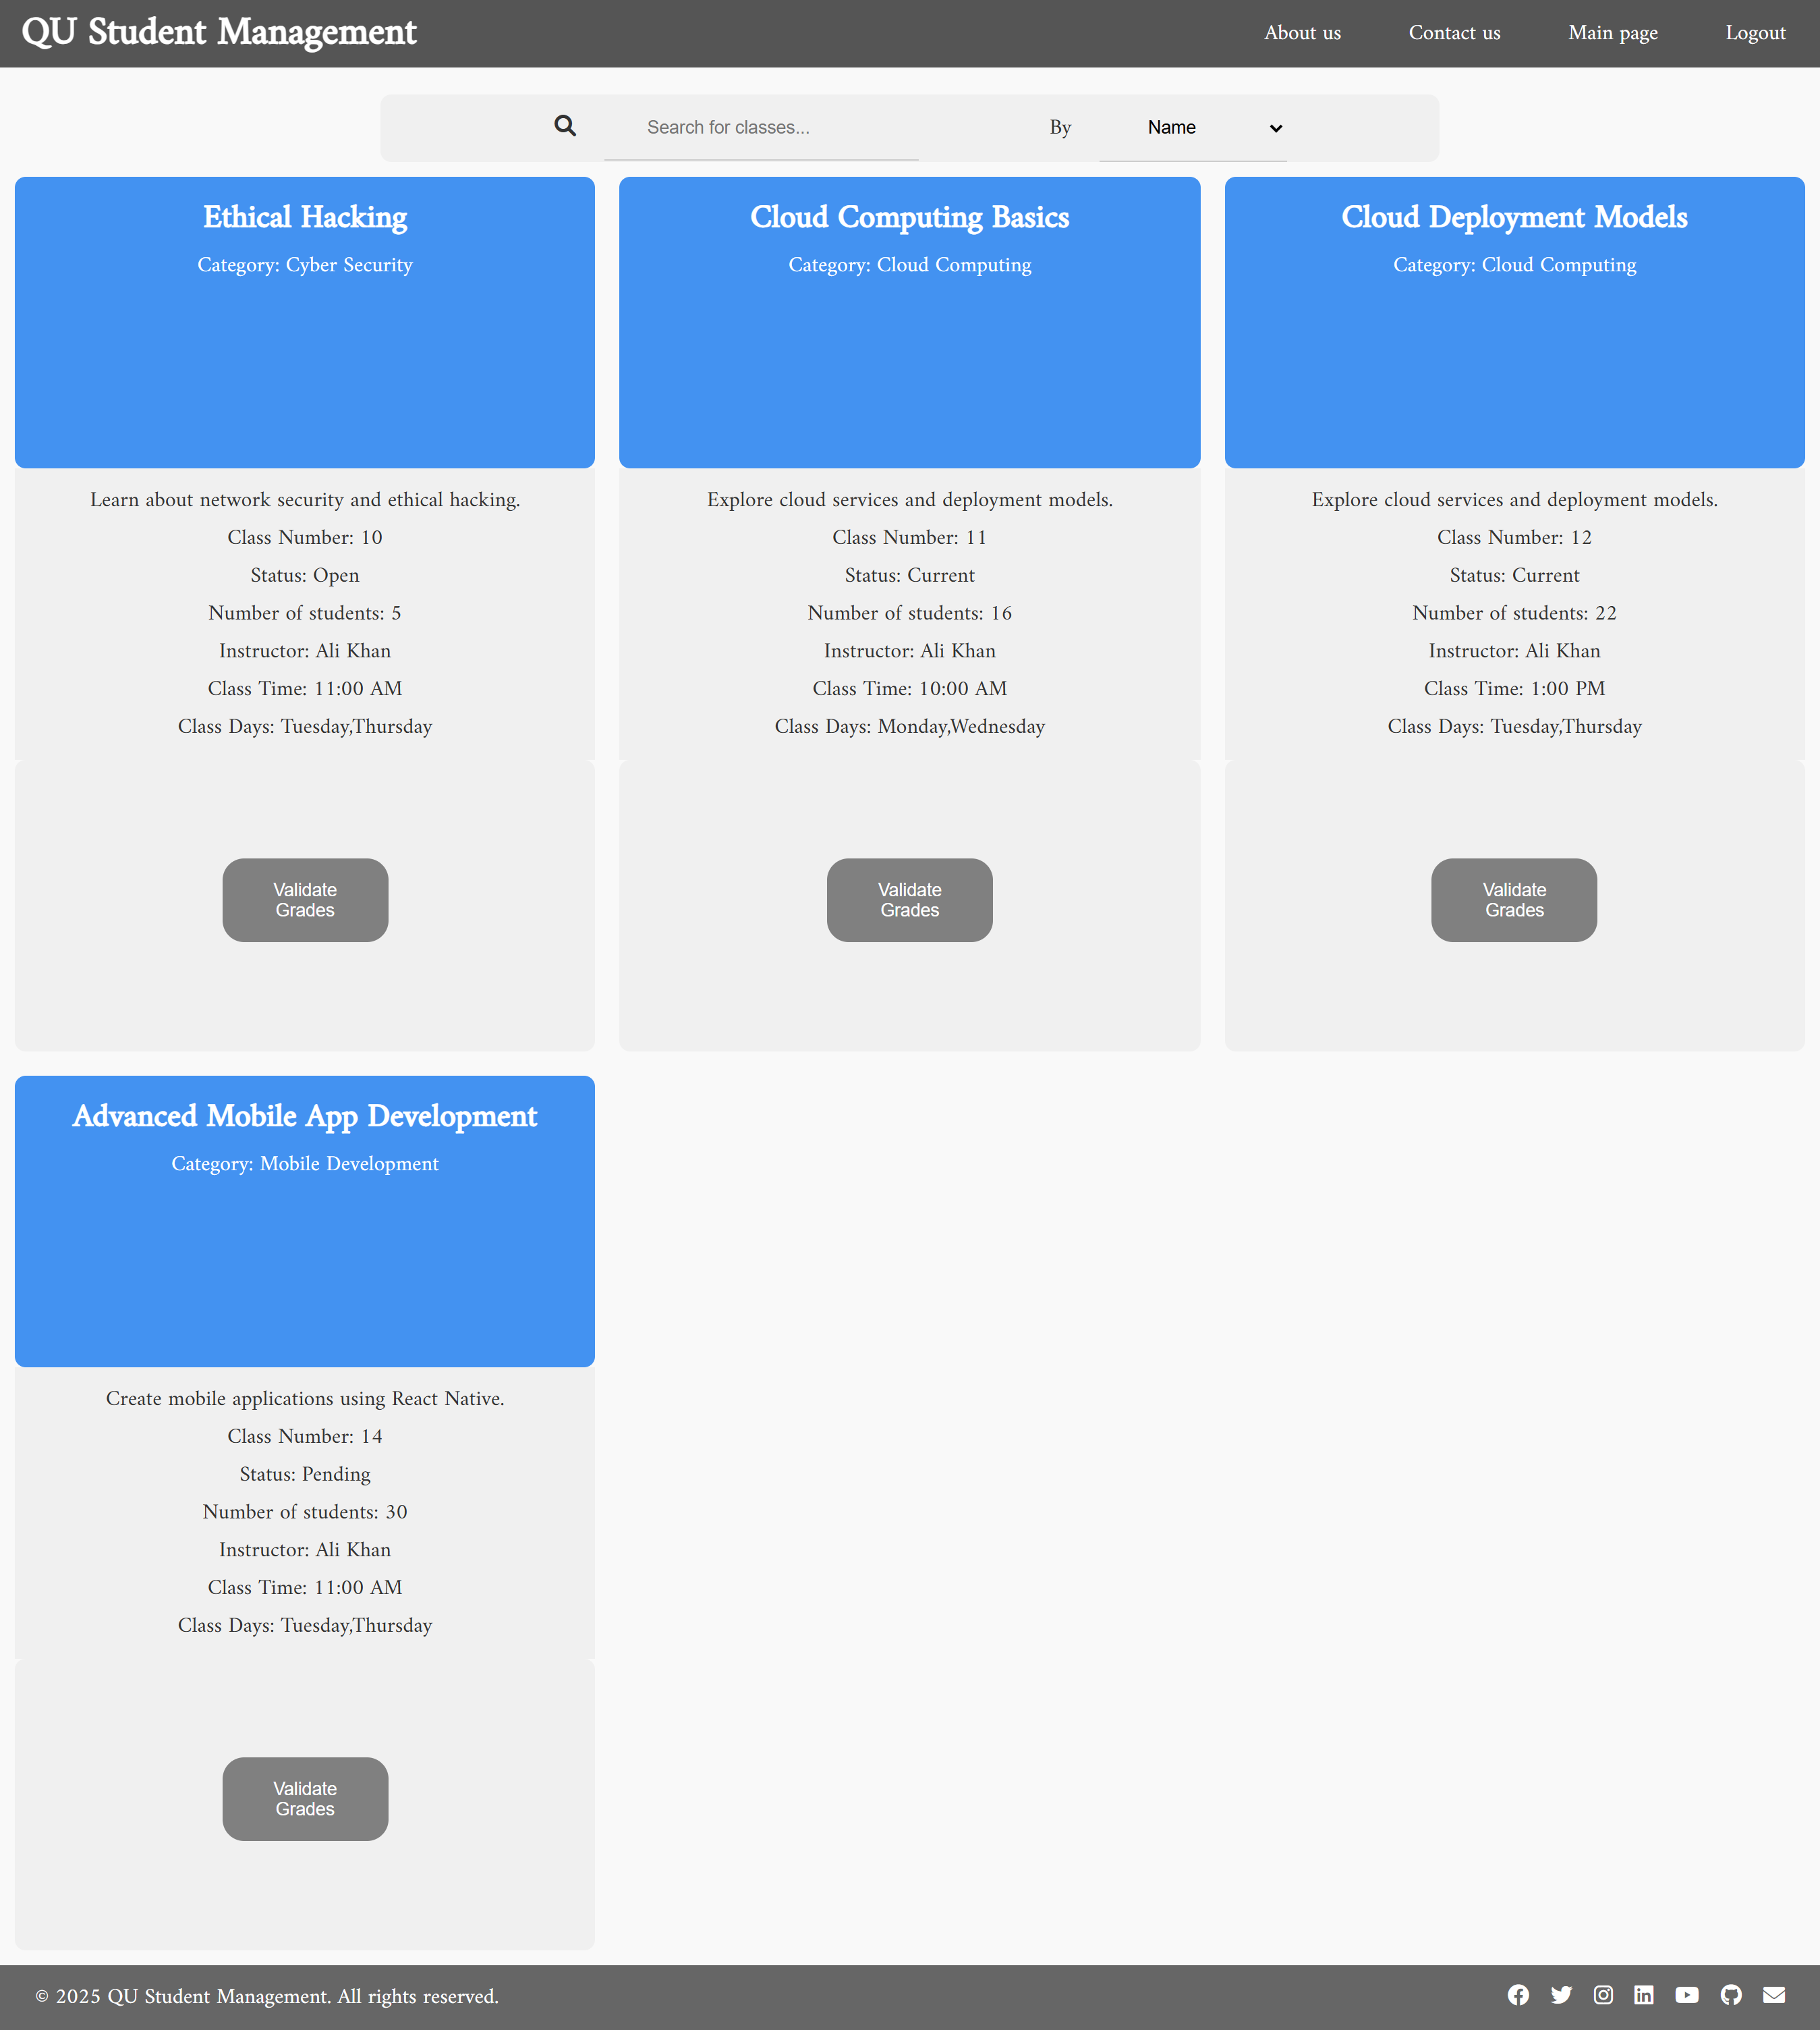

From Admin main page it will be changed to Closed:

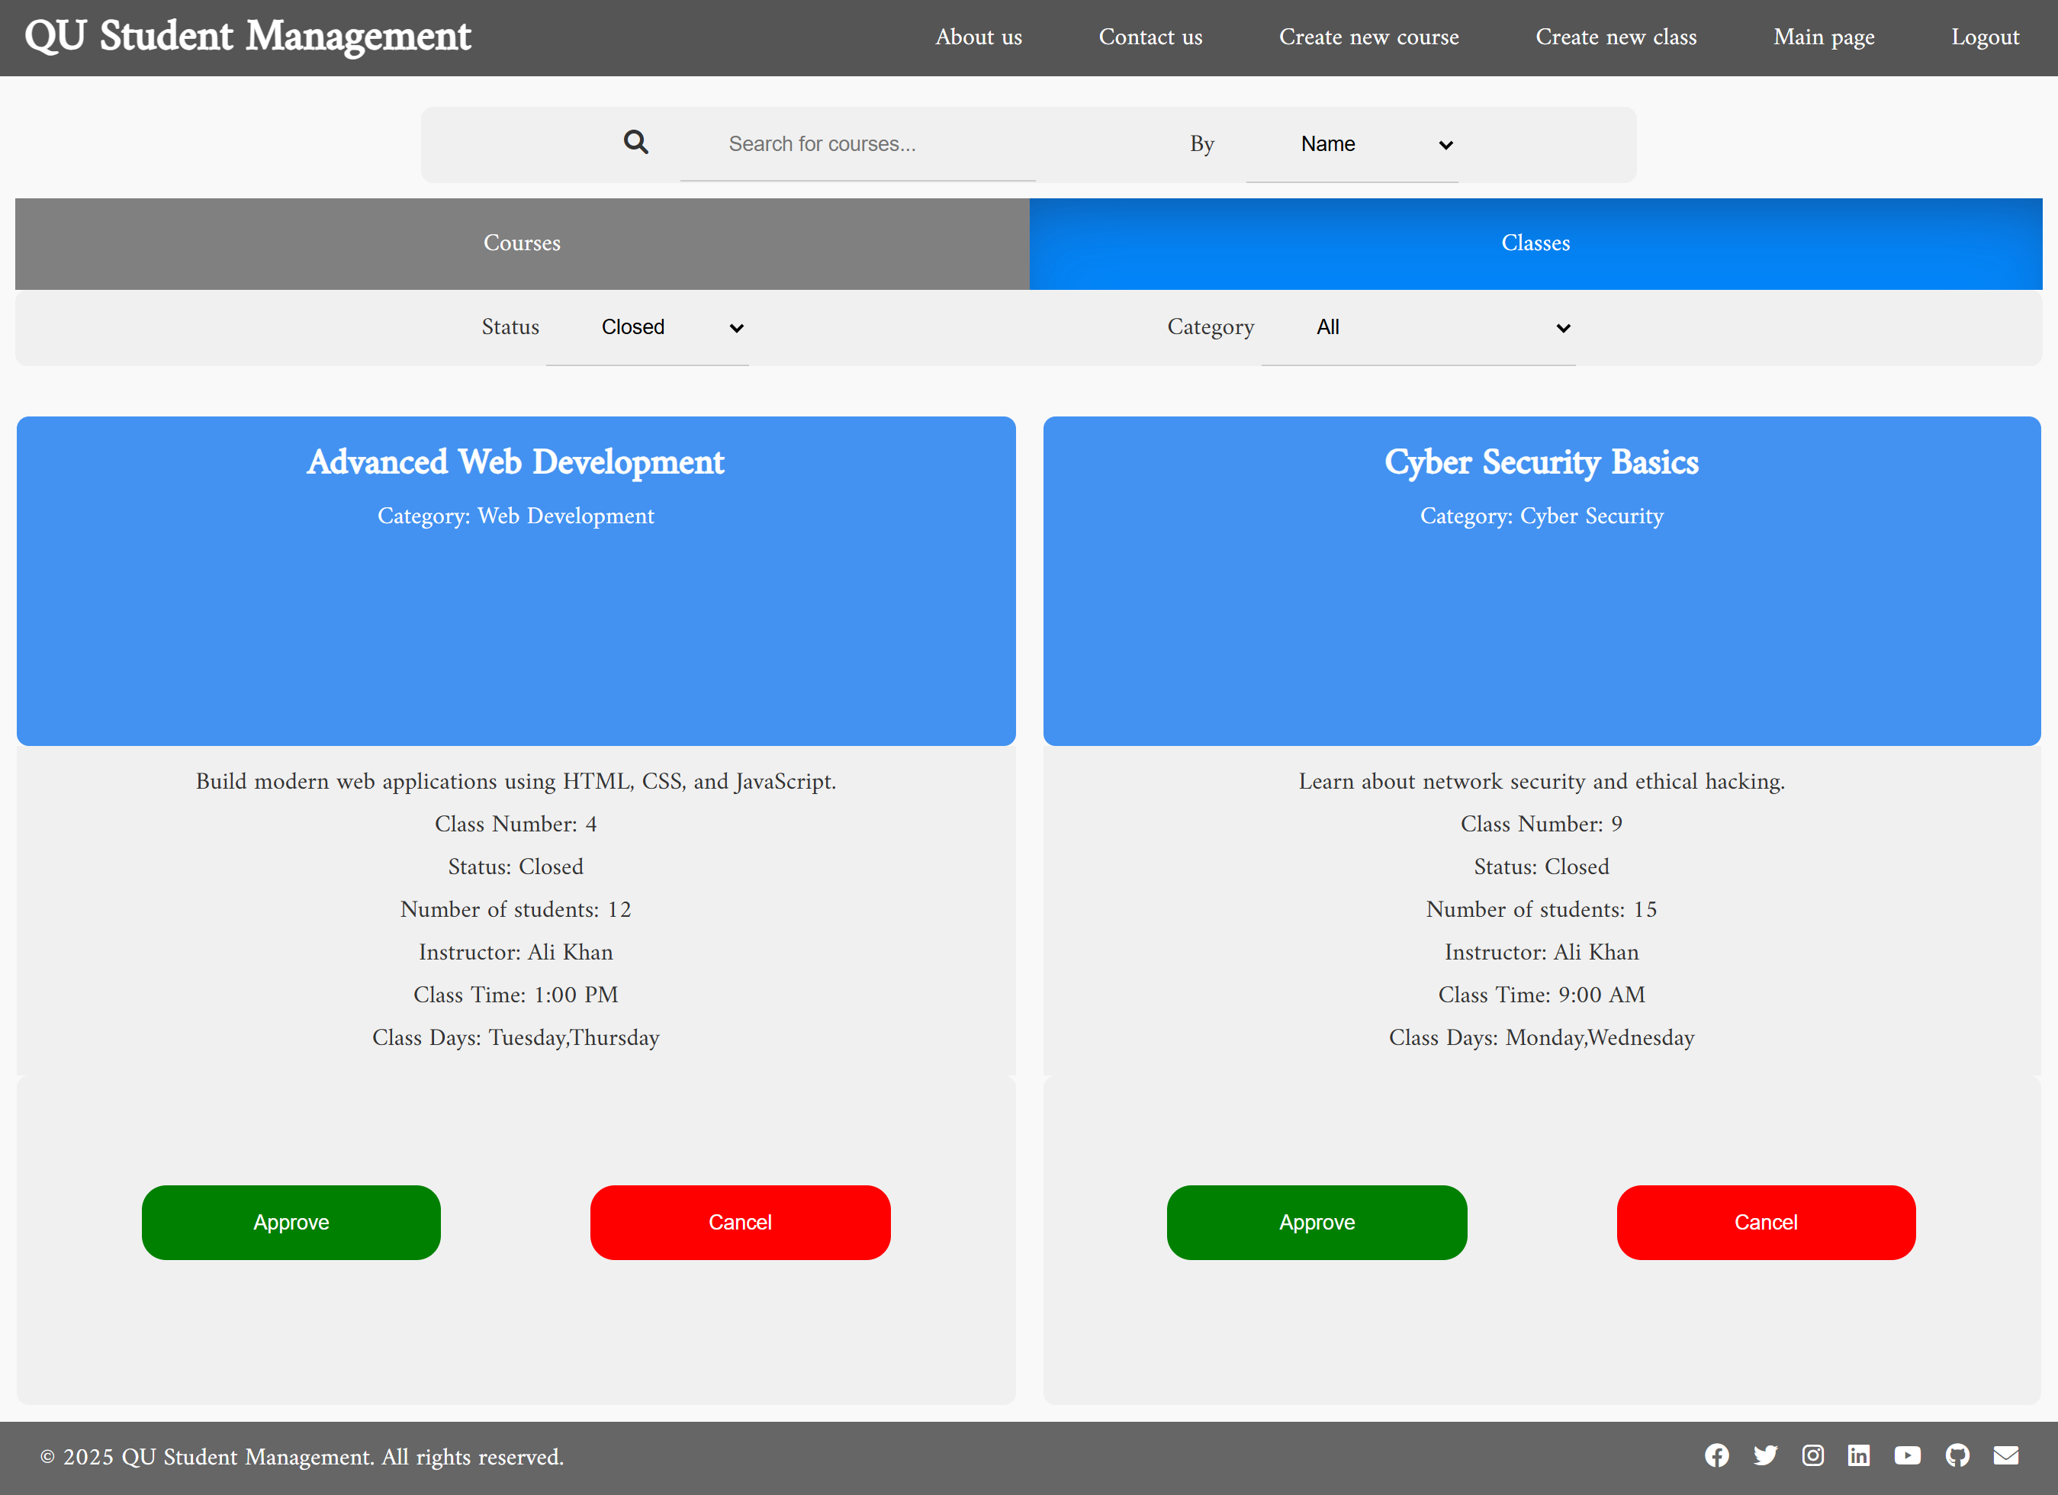

From Student Mohammed learning path page:

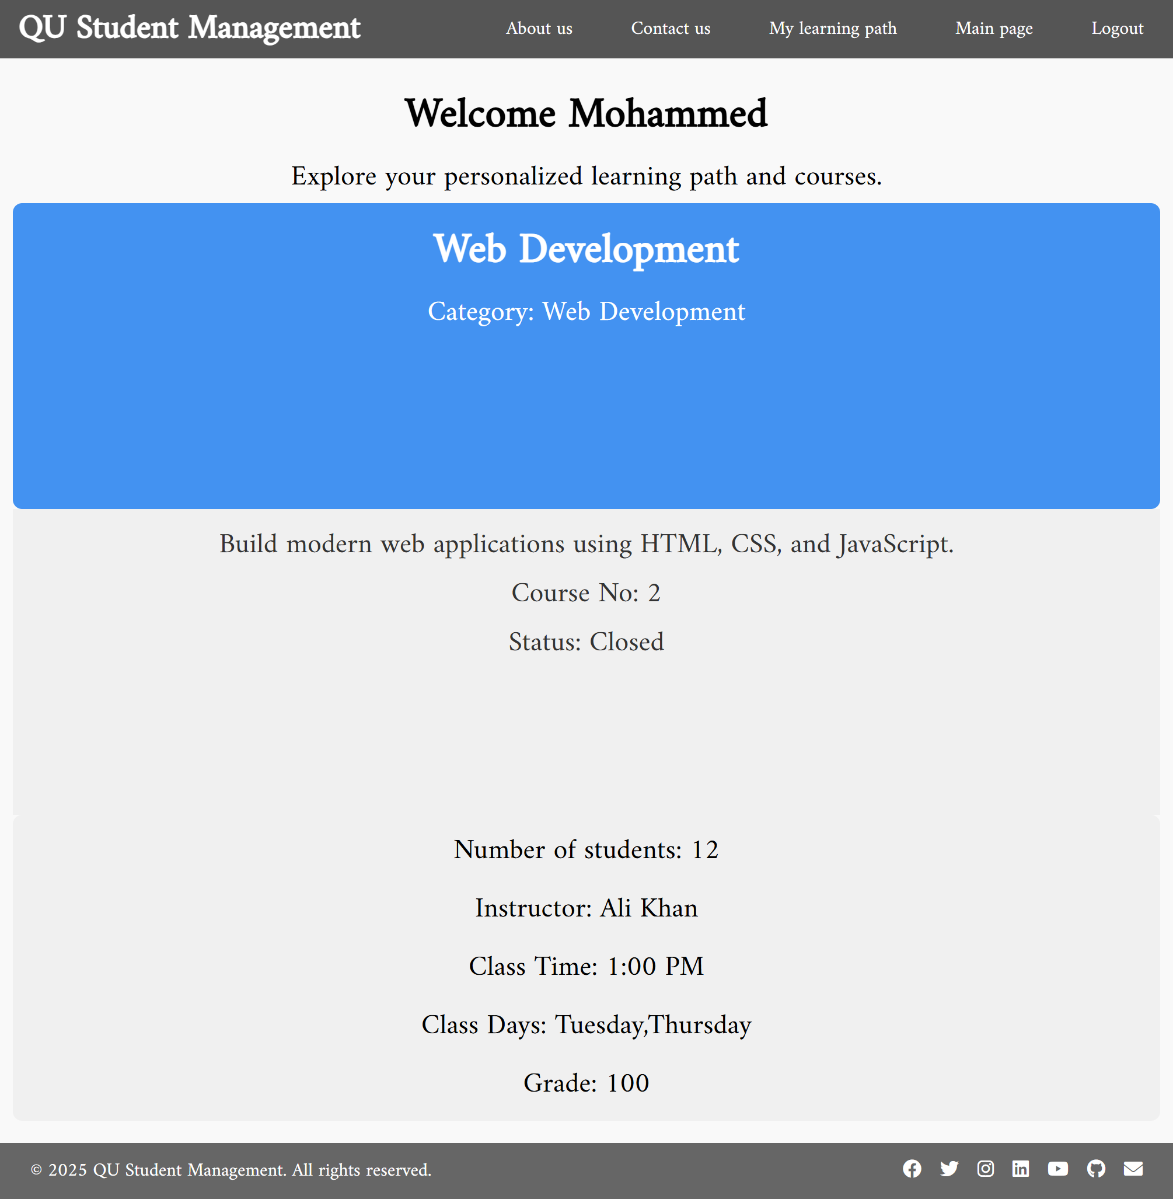

# Discussion of the project contribution of each team member

We used Microsoft teams to host our meetings, all meetings are documented in github > websiteDoc repo

|  |  |
| --- | --- |
| **Student name** | **Student contributions** |
| Mohammed Abdullah | Create Web APIs and Usecase 2 & 4 |
| Ibrahim Eyad Aboulibdah | Create the web design and Usecase 1 & 3 |
| Fahad Salem Al-Eida | Implement web design and Usecase 5 & 6 |
|  |  |
|  |  |